**Exercise 12: Supervised and unsupervised pattern recognition**

**Pablo Castro Ilundain**

**Question 1)**

Matlab code

**Question 2)**

Validation performance for the first dataset:

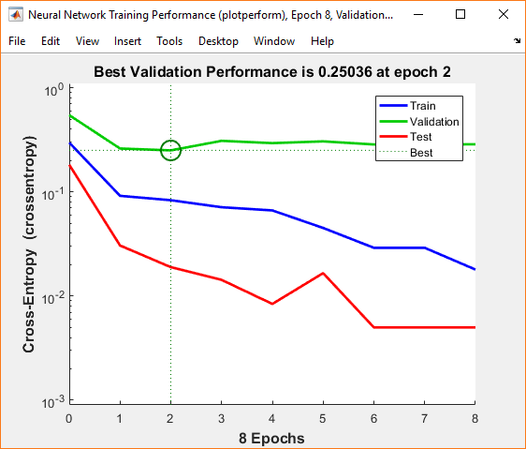

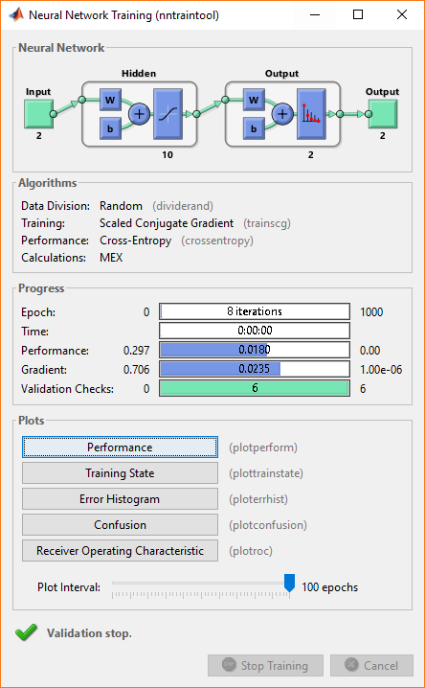

The training stopped because the validation stopped at 8 iterations.

Validation performance for the second dataset:

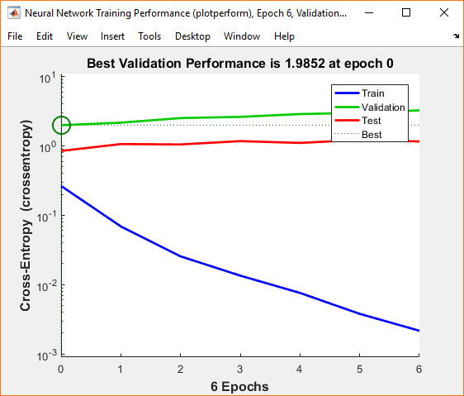

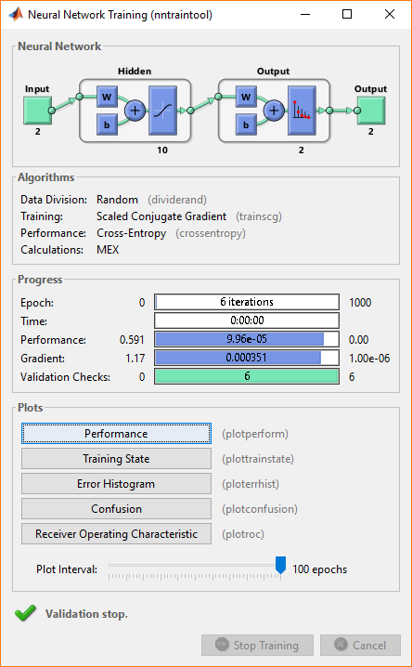

The training stopped because the validation stopped at 6 iterations.

Validation performance for the third dataset:

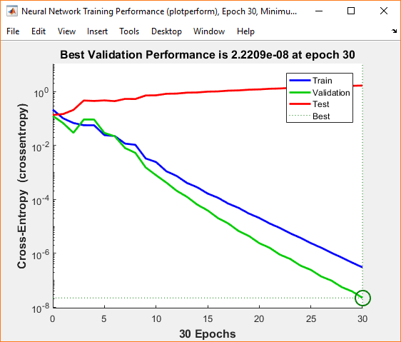

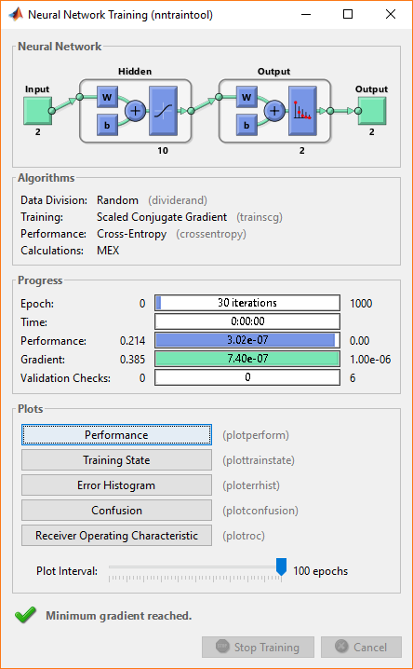

The training stopped because the minimum gradient was reached at 30 iterations.

In terms of overall performance, we can conclude that the neural network that performed the best was the third one with a 0.214 performance value. Probably this was caused because the number of iterations was larger than the other networks which means that the network learned more time and could result in a better performance.

**Question 3)**

The features used for clustering should not be normalized because we want the solving algorithm to calculate the outputs as fast as possible and if the features are normalized, the algorithm may not work as easy as if the features weren’t normalized (even though the ratios of the distances are the same normalized and not normalized). This means that for example, two vectors could be classified into different clusters but when the features are normalized, the algorithm could not find the distance big enough to separate them as they should be.

**Question 4)**

1. Their shapes depend on what function was used to calculate the distance:

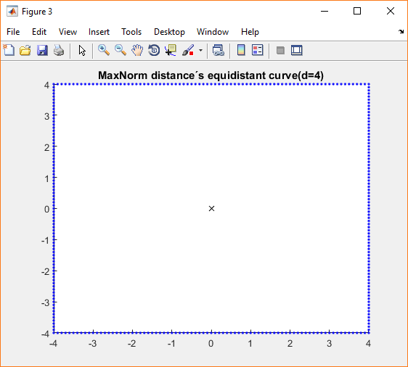

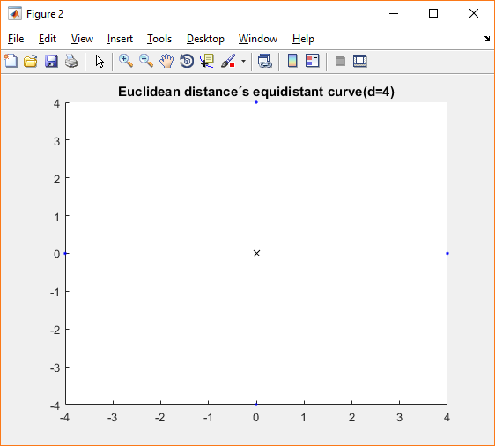

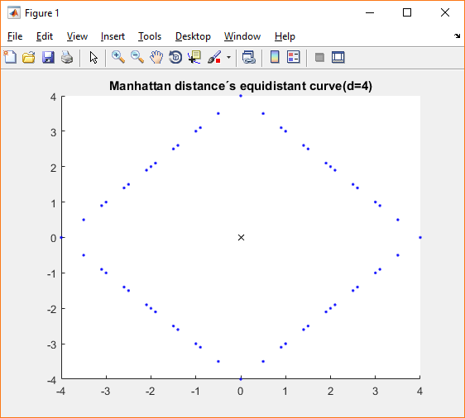

For the MaxNorm function, the shape is a square, for the Euclidean function the shape is a rhombus/diamond with not much points and finally, the Manhattan function shaped into a rhombus/diamond too but with much more points.

1. In 3D the shapes would be, respectively, a cube and 2 diamonds/ rhombuses.